15th May 2026

RE | Our RE topic is ‘To the Ends of the Earth’.
Spellings | answer  question  purpose  therefore  experiment  heart  history  fruit  earth  island  material  science
Reading | Please continue to record weekly in reading diaries.
Maths | Have a look at money at home- we are going to be learning about money, adding and subtracting it. See what amounts you can add and subtract at home and record in your books.
Geography/writing | Find out some information about volcanoes and create a poster for the classroom.
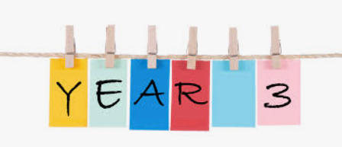
Mrs Gee

