Maths
To finish our topic on length, Mass and Capacity. Make a list of items at home that show measures eg. Drink can – 330ml, bag of flour 200g
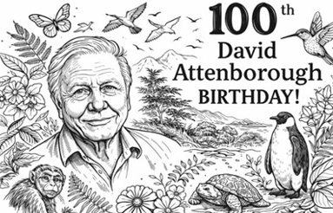
As it is David Attenborough’s 100th Birthday today, design a poster on the paper provided on fascinating facts you can find out about him. Search the internet with a grown up, visit the library or watch TV programs that he has made to help you.
READING
Read your reading book at least 3 times a week and record in the reading diaries. We are working towards our next reading reward.
Spellings -
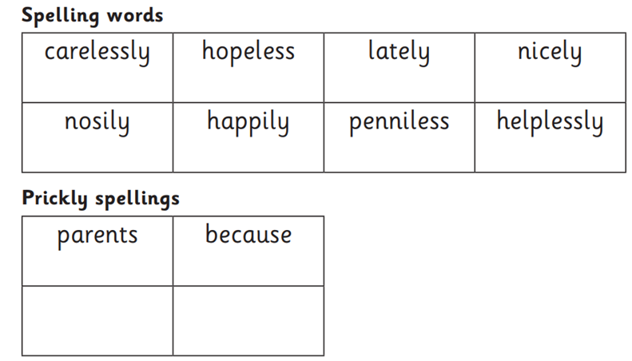
Additional Information
- Year 2 have PE on WEDNESDAY. ENRICHMENT DAY ON FRIDAY THE CHILDREN WILL NEED PE KITS

ADVANCED NOTICE
After HALF TERM, Year 2 will be having a REAL SUPERHERO dress up day. We will be focusing on real life heroes in line with our work on Emmeline Pankhurst, Rosa Parkes and Martin Luther King. (Other real heroes through time that have made a difference could include Florence Nightingale, Neil Armstrong etc)

Have a great weekend!
Mrs Harris
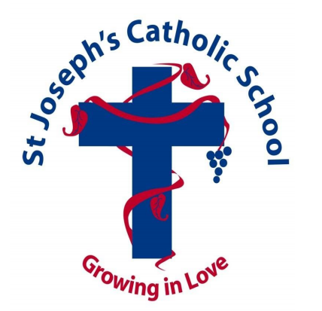

Friday 8TH May 2026
Word of the Week: WITNESS

