Science Curriculum Intent
Part 1 : Subject Knowledge
Part 2: Disciplinary Knowledge

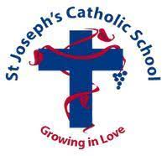

Year 2
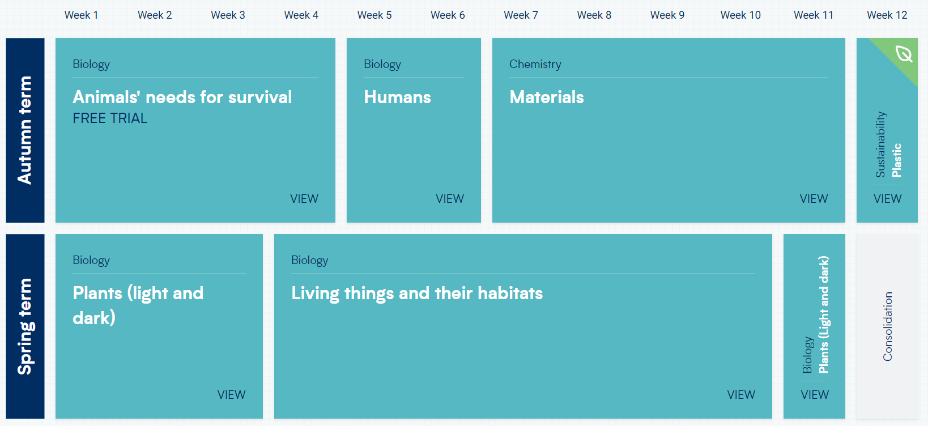
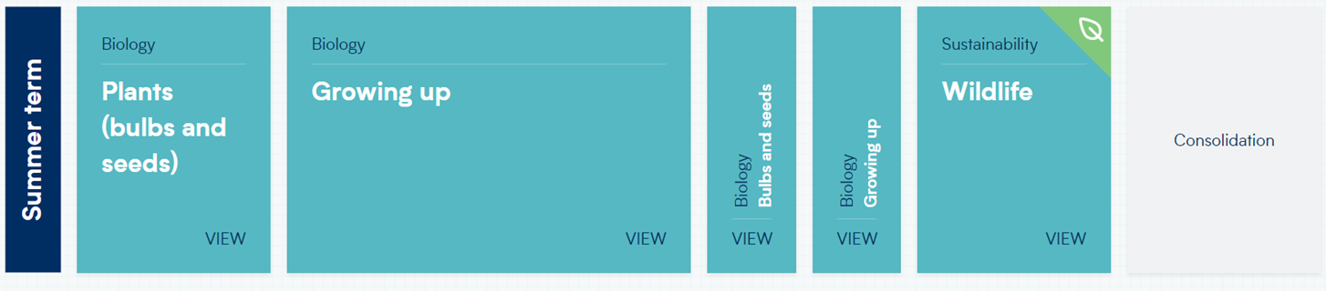
Year 3
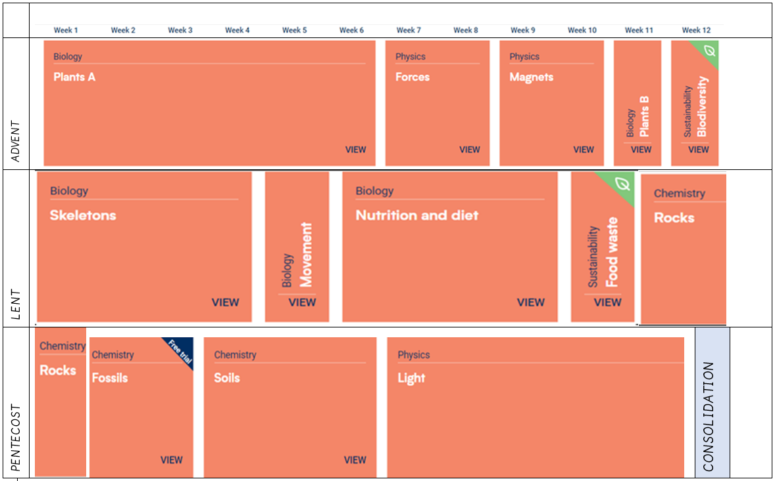
Year 5
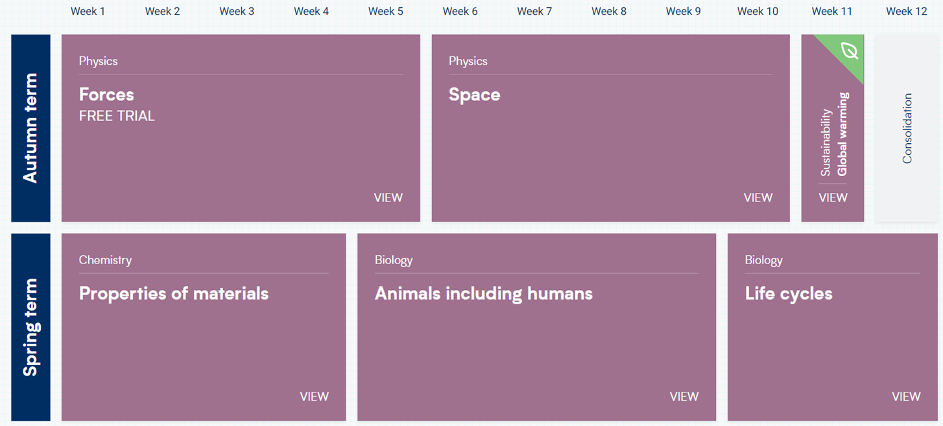
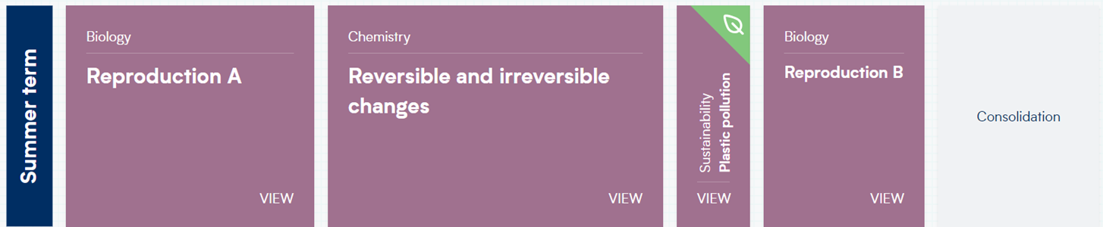
Year 6
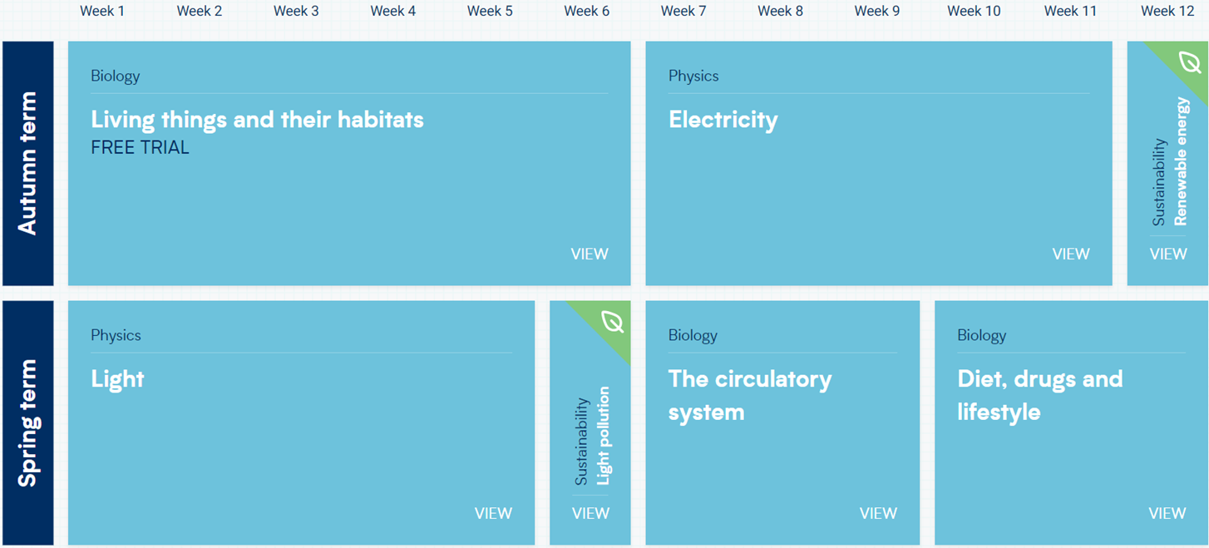
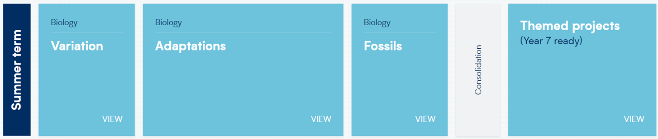
PART 1 : SUBJECT KNOWLEDGE
Animals including Humans
Foundation 1
•Knows how to talk about some of the things I have observed such as plants, animals, natural and found objects.
Knows about and understands the key features of the life cycle of a plant and an animal.
Foundation 2
• Explore the natural world around them, making observations and drawing pictures of animals and plants;
• Knows how to talk about some of the things I have observed such as plants, animals, natural and found objects.
• Knows how to show care and concern for living things and the environment
• Knows how to describe what they see, hear and feel whilst outside.
Year 1 |  | Year 2 | Year 3 |  | Year 4 | Year 5 |  | Year 6
Pupils will know:  • Identify and name  a variety of  common animals  including fish,  amphibians,  reptiles, birds and  mammals  • Identify and name  a variety of  common animals  that are carnivores,  herbivores and  omnivores  • Describe and  compare the  structure of a  variety of common  animals (fish,  amphibians,  reptiles, birds and  mammals including  pets)  • Identify, name,  draw and label the  basic parts of the body |  | Pupils will know:  • Notice that animals,  including humans,  have offspring  which grow into  adults  • Find out about and  describe the basic  needs of animals,  including humans,  for survival (water,  food and air)  • Describe the  importance for  humans of exercise,  eating the right  amounts of  different types of  food, and hygiene | Pupils will know:  • Identify that  animals, including  humans, need the  right types and  amount of nutrition,  and that they  cannot make their  own food; they get  nutrition from what  they eat  • Identify that  humans and some  other animals have  skeletons and  muscles for  support, protection  and movement |  | Pupils will know:  • Describe the simple  functions of the  basic parts of the  digestive system in  humans  • Identify the  different types of  teeth in humans  and their simple  functions  • Construct and  interpret a variety  of food chains,  identifying  producers,  predators and prey | Pupils will know:  • Describe the  changes as humans  develop to old age |  | Pupils will know:  • Identify and name  the main parts of  the human  circulatory system,  and describe the  functions of the  human body and  say which part of  the body is  associated with  each sense  heart, blood vessels  and blood  • Recognise the  impact of diet,  exercise, drugs and  lifestyle on the way  their bodies  function  • Describe the ways  in which nutrients  and water are  transported within  animals, including humans
Coverage through year groups
ADVENT 1, LENT 2 | ADVENT 1, LENT 1 PENTECOST 1, |  | PENTECOST 1  PENTECOST 2 | PENTECOST 2 |  | PENTECOST 2 | LENT 2

Living Things and Their Habitats
Foundation 1
• Knows to show care and concern for living things and the environment
- Knows how to recognise some environments that are different to the one in which they live.
Foundation 2
- Knows how to ask questions about aspects of my familiar world such as the place where I live or the natural world.•
• Knows that they need to respect and care for the natural environment and all living things. (starting to)
• Know some similarities and differences between the natural world around them and contrasting environments

Year 2 | Year 4 |  | Year 5 | Year 6
Pupils will know:  • Explore and compare the  differences between things that  are living, dead, and things that  have never been alive  • Identify that most living things  live in habitats to which they are  suited and describe how  different habitats provide for the  basic needs of different kinds of  animals and plants, and how  they depend on each other  • Identify and name a variety of  plants and animals in their  habitats, including  microhabitats  • Describe how animals obtain  their food from plants and other  animals, using the idea of a  simple food chain, and identify  and name different sources of  food | Pupils will know:  • Recognise that living things can  be grouped in a variety of ways  • explore and use classification  keys to help group, identify and  name a variety of living things in  their local and wider  environment  • Recognise that environments  can change and that this can  sometimes pose dangers to  living things |  | Pupils will know:  • Describe the differences in the  life cycles of a mammal, an  amphibian, an insect and a bird  • Describe the life process of  reproduction in some plants and  animals | Pupils will know:  • Describe how living things are  classified into broad groups  according to common  observable characteristics and  based on similarities and  differences, including microorganisms, plants and animals  • Give reasons for classifying  plants and animals based on specific characteristics
Coverage through Year Groups
LENT 1  PENTECOST 2 | ADVENT 1  LENT 1  PENTECOST 1 | LENT 2  PENTECOST 1 PENTCOST 2 |  | ADVENT 1

Plants
Foundation 1
• Knows how to plant seeds and care for growing plants.
Foundation 2
• • Knows how to talk about some of the things I have observed such as plants, animals, natural and found objects.
Year 1 | Year 2 | Year 3
Pupils will know:  • Identify and name a variety of common wild  and garden plants, including deciduous and  evergreen trees  • Identify and describe the basic structure of a  variety of common flowering plants, including  trees | Pupils will know:  • Observe and describe how seeds and bulbs  grow into mature plants  • Find out and describe how plants need water,  light and a suitable temperature to grow and  stay healthy | Pupils will know:  • Identify and describe the functions of  different parts of flowering plants: roots,  stem/trunk, leaves and flowers  • Explore the requirements of plants for life and  growth (air, light, water, nutrients from soil,  and room to grow) and how they vary from  plant to plant  • Investigate the way in which water is  transported within plants  • Explore the part that flowers play in the life  cycle of flowering plants, including pollination,  seed formation and seed dispersal
Coverage through Year Groups
Spring 1, Spring 5  Summer 1, Summer 2 | LENT 1 LENT 2  PENTECOST 1 PENTECOST 2 | ADVENT 1 ADVENT 2

Materials
Foundation 1
- Knows about and notices features of objects in the environment
- Knows how to use all their senses in hands-on exploration of natural materials.
- Knows how to talk about the differences between materials and changes they notice.
- Knows how to explore collections of materials with similar and/or different properties.

Materials
Year 1 | Year 2 | Year 5
Pupils will know:  • Distinguish between an object and the  material from which it is made  • Identify and name a variety of everyday  materials, including wood, plastic, glass,  metal, water, and rock  • Describe the simple physical properties of a  variety of everyday materials  • Compare and group together a variety of  everyday materials on the basis of their  simple physical properties | Pupils will know:  • Identify and compare the suitability of a  variety of everyday materials, including  wood, metal, plastic, glass, brick, rock, paper  and cardboard for particular uses  • Find out how the shapes of solid objects made  from some materials can be changed by  squashing, bending, twisting and stretching | Pupils will know:  • Compare and group together everyday  materials on the basis of their properties,  including their hardness, solubility,  transparency, conductivity (electrical and  thermal), and response to magnets  • know that some materials will dissolve in  liquid to form a solution, and describe how to  recover a substance from a solution  • use knowledge of solids, liquids and gases to  decide how mixtures might be separated,  including through filtering, sieving and  evaporating  • Give reasons, based on evidence from  comparative and fair tests, for the particular  uses of everyday materials, including metals,  wood and plastic  • Demonstrate that dissolving, mixing and  changes of state are reversible changes  • Explain that some changes result in the  formation of new materials, and that this kind  of change is not usually reversible, including  changes associated with burning and the  action of acid on bicarbonate of soda
Coverage through Year Groups
ADVENT 1 | ADVENT 1 | LENT 1 PENTECOST 2

Rocks
Year 3

Pupils will know:

• Compare and group together different kinds of rocks on the basis of their appearance and simple physical properties
• Describe in simple terms how fossils are formed when things that have lived are trapped within rock
• Recognise that soils are made from rocks and organic matter

Coverage through Year Groups
PENTECOST 1 PENTECOST 2

State of Matter
Foundation 2
- Understand some important processes and changes in the natural world around them, including the seasons and changing states of matter.
- Knows about and is developing an understanding of growth, decay and changes over time.

Year 4

Pupils will know:

• Compare and group materials together, according to whether they are solids, liquids or gases
• Observe that some materials change state when they are heated or cooled, and measure or research the temperature at which this happens in
degrees Celsius (°C)
• Identify the part played by evaporation and condensation in the water cycle and associate the rate of evaporation with temperature

Coverage through Year Groups
LENT 1

Electricity
Year 4 |  | Year 6
Pupils will know:  • Identify common appliances that run on electricity  • Construct a simple series electrical circuit, identifying and naming its  basic parts, including cells, wires, bulbs, switches and buzzers  • Identify whether or not a lamp will light in a simple series circuit, based  on whether or not the lamp is part of a complete loop with a battery  • Recognise that a switch opens and closes a circuit and associate this  with whether or not a lamp lights in a simple series circuit  • Recognise some common conductors and insulators, and associate  metals with being good conductors |  | Pupils will know:  • Associate the brightness of a lamp or the volume of a buzzer with the  number and voltage of cells used in the circuit  • Compare and give reasons for variations in how components function,  including the brightness of bulbs, the loudness of buzzers and the on/off  position of switches  • Use recognised symbols when representing a simple circuit in a diagram
Coverage through the Year Groups
LENT 2 | AUTUMN 2

Earth and Space
Year 5

Pupils will know:

• Describe the movement of the Earth and other planets relative to the sun in the solar system
• Describe the movement of the moon relative to the Earth
• Describe the sun, Earth and moon as approximately spherical bodies
• Use the idea of the Earth’s rotation to explain day and night and the apparent movement of the sun across the sky

Coverage through the Year Groups
ADVENT 2

Seasonal Changes
Foundation 2
• Knows and understands the effect of changing seasons on the natural world around them.

Year 1

Pupils will know:

• Observe changes across the 4 seasons
• Observe and describe weather associated with the seasons and how day length varies

Coverage through Year Groups
ADVENT 1 ADVENT 2 LENT 1 PENTECOST 2

Sound
Year 4
Pupils will know:

• Identify how sounds are made, associating some of them with something vibrating
• Recognise that vibrations from sounds travel through a medium to the ear
• Find patterns between the pitch of a sound and features of the object that produced it
• Find patterns between the volume of a sound and the strength of the vibrations that produced it
• Recognise that sounds get fainter as the distance from the sound source increases
Spring
Coverage through Year Groups
ADVENT 1

Light
Year 3 | Year 6
Pupils will know:  Recognise that they need light in order to see things and that dark is the  absence of light  • Notice that light is reflected from surfaces  • Recognise that light from the sun can be dangerous and that there are  ways to protect their eyes  • Recognise that shadows are formed when the light from a light source is  blocked by an opaque object  • Find patterns in the way that the size of shadows change | Pupils will know:  • Recognise that light travels in straight lines  • Use the idea that light travels in straight lines to explain that objects are  seen because they give out or reflect light into the eye  • Explain that we see things because light travels from light sources to our  eyes or from light sources to objects and then to our eyes  • Use the idea that light travels in straight lines to explain why shadows  have the same shape as the objects that cast them
Coverage through the Year Groups
PENTECOST 2 | LENT 1

Forces and Magnets
Foundation 1
• Knows how to explore and talk about different forces they can feel.
Year 3 | Year 5
Pupils will know:  • Compare how things move on different surfaces  • Notice that some forces need contact between 2 objects, but magnetic  forces can act at a distance  • Observe how magnets attract or repel each other and attract some  materials and not others  • Compare and group together a variety of everyday materials on the  basis of whether they are attracted to a magnet, and identify some  magnetic materials  • Describe magnets as having 2 poles  • predict whether 2 magnets will attract or repel each other, depending on which poles are facing | Pupils will know:  • Explain that unsupported objects fall towards the Earth because of the  force of gravity acting between the Earth and the falling object  • Identify the effects of air resistance, water resistance and friction, that act between moving surfaces  • Recognise that some mechanisms including levers, pulleys and gears  allow a smaller force to have a greater effect
Coverage through the Year Groups
ADVENT 2 | ADVENT 1

Evolution and Inheritance
Year 6
Pupils will know:

• Recognise that living things have changed over time and that fossils provide information about living things that inhabited the Earth millions of years
ago
• Recognise that living things produce offspring of the same kind, but normally offspring vary and are not identical to their parents
• Identify how animals and plants are adapted to suit their environment in different ways and that adaptation may lead to evolution

Coverage through the Year Groups
PENTECOST 1 PENTECOST 2

PART 2 : DISCIPLINARY KNOWLEDGE

ASK QUESTIONS
Foundation Stage
Working Scientifically Pupils will know how to:
To begin to ask simple questions with support
Year 1 | Year 2 | Year 3 | Year 4 | Year 5 | Year 6
Working Scientifically  Pupils will know how to:  • Ask simple questions. | Working Scientifically  Pupils will know how to:  • Ask simple  questions and recognise that they can be  answered in different ways. | Working Scientifically  Pupils will know how to:  • Ask questions and  understand there  are different  enquiry types they  could use to answer  them. | Working Scientifically  Pupils will know how to:  • Ask relevant  questions and use  different types of  scientific enquiry  to answer them. | Working Scientifically  Pupils will know how to:  • Ask scientific  questions and begin  to understand  which questions  would be best  suited to each  enquiry type. | Working Scientifically  Pupils will know how to:  • Ask relevant  scientific questions  and choose which  enquiry type would  be best suited to  answer them

PLAN
Year 1 | Year 2 | Year 3 | Year 4 | Year 5 | Year 6
Working Scientifically  Pupils will know how to:  Verbally state what  they are going to  investigate.  comparative and  fair tests. | Working Scientifically  Pupils will know how to:  • Make simple  predictions based  on a question.  • Identify what they  will change and  keep the same. | Working Scientifically  Pupils will know how to:  • Make relevant  predictions.  • Identify what they  will change, observe  and keep the same.  • With support, set up  simple practical  enquiries. | Working Scientifically  Pupils will know how to:  • Make predictions  based on simple  scientific  knowledge.  • Identify what they  will change, observe  or measure and  keep the same.  • Set up simple  practical  enquiries, | Working Scientifically  Pupils will know how to:  • Make predictions  based on scientific  knowledge.  • With support, plan  different types of  scientific enquiry.  Where appropriate,  identify the  dependent, independent and controlled  variables. | Working Scientifically  Pupils will know how to:  • Make predictions  based on scientific  knowledge.  • Plan different  types of scientific  enquiries to  answer questions,  including  recognising and controlling  variables where  necessary.

MAKE OBSERVATIONS
Foundation Stage
Working Scientifically Pupils will know how to:
Begin to observe closely with support
Year 1 | Year 2 | Year 3 | Year 4 | Year 5 | Year 6
Working Scientifically  Pupils will know how to:  • Observe closely. • | Working Scientifically  Pupils will know how to:  Observe closely,  using simple  equipment. | Working Scientifically  Pupils will know how to:  • Begin to use  scientific equipment  to make  observations. | Working Scientifically  Pupils will know how to:  • Make systematic  and careful  observations. | Working Scientifically  Pupils will know how to:  • Use a range of  scientific equipment  to make systematic  and careful  observations | Working Scientifically  Pupils will know how to:  • Use a range of  scientific equipment  to make systematic  and careful  observations with  increased mplexity

TAKE MEASUREMENTS
Year 1 | Year 2 | Year 3 | Year 4 | Year 5 | Year 6
Working Scientifically  Pupils will know how to:  • Carry out simple  tests using non-standard  measurements  when appropriate. | Working Scientifically  Pupils will know how to:  • Perform simple  tests using  standard units  when appropriate. | Working Scientifically  Pupils will know how to:  • Carry out tests and  simple experiments  and take  measurements  using standard  units. | Working Scientifically  Pupils will know how to:  • Take accurate  measurements  using standard  units, using a  range of  equipment,  including  thermometers and  data loggers. | Working Scientifically  Pupils will know how to:  • Take accurate  measurements  using a range of  scientific  equipment. Start to  take repeat  readings when  appropriate. | Working Scientifically  Pupils will know how to:  • Take  measurements,  using a range of  scientific  equipment, with  increasing  accuracy and  precision, taking  repeat readings  when appropriate.

GATHER, RECORD AND CLASSIFY DATA
Foundation Stage
Working Scientifically Pupils will know how to:
Begin to sort objects and talk about how they have grouped the objects with support

Year 1 | Year 2 | Year 3 | Year 4 | Year 5 | Year 6
Working Scientifically  Pupils will know how to:  • Gather and record  simple data.  • Sort objects and  living things into  groups based on  simple properties. | Working Scientifically  Pupils will know how to:  • Gather and record  data to help in  answering  questions.  • Identifying and  classifying. | Working Scientifically  Pupils will know how to:  • Gather and record  data in different  ways to help  answer questions.  • Recording findings  using simple  scientific  language,  drawings, labelled  diagrams, bar  charts, and tables. | Working Scientifically  Pupils will know how to:  • Gather, record and  classify data in a  variety of ways to  help in answering  questions.  • Record findings  using simple  scientific  language,  drawings, labelled  diagrams, keys,  bar charts, and  tables. | Working Scientifically  Pupils will know how to:  • Gather, record and  classify data with  increasing  complexity to help  in answering  questions.  • Record data using  scientific diagrams  and labels,  classification keys,  tables, bar and  line graphs. | Working Scientifically  Pupils will know how to:  • Record data and  results of  increasing  complexity using  scientific diagrams  and labels,  classification keys,  tables, scatter  graphs, bar and  line graphs
PRESENT FINDINGS
Year 1 | Year 2 | Year 3 | Year 4 | Year 5 | Year 6
Working Scientifically  Pupils will know how to:  • Explain what they  found out to an  adult or a partner.  . | Working Scientifically  Pupils will know how to:  • Talk about what  they have found  out and how they  found it out.  (non-statutory) | Working Scientifically  Pupils will know how to:  • Report on findings  from enquiries,  including oral and  written  explanations. | Working Scientifically  Pupils will know how to:  • Report on findings  from enquiries,  including oral and  written  explanations,  displays or  presentations of  results and  conclusions. | Working Scientifically  Pupils will know how to:  • Report and present  findings from  enquiries, including conclusions.  • Begin to identify  causal relationships  in oral and written  forms such as  displays and other  presentations. | Working Scientifically  Pupils will know how to:  • Report and  present findings  from enquiries,  including  conclusions,  causal  relationships and  explanations of  and a degree of  trust in results, in  oral and written  forms such as  displays and other  presentations
ANSWER QUESTIONS AND MAKE CONCLUSIONS
Foundation Stage
Working Scientifically Pupils will know how to:
Begin to answer simple questions with support
Year 1 | Year 2 | Year 3 | Year 4 | Year 5 | Year 6
Working Scientifically  Pupils will know how to:  • Answer simple  questions. | Working Scientifically  Pupils will know how to:  • Use their  observations and  ideas to suggest  answers to  questions. | Working Scientifically  Pupils will know how to:  • Make simple  conclusions.  • Use results, findings  or observations to  answer questions. | Working Scientifically  Pupils will know how to:  • Use straightforward scientific  evidence to answer  questions or to  support their  findings.  • Use results to draw  simple conclusions.  • Begin to identify  differences,  similarities or  changes related to  simple ideas or  processes. | Working Scientifically  Pupils will know how to:  • Use scientific  evidence to answer  questions.  • Make conclusions  based on scientific  evidence and from  their own testing  and findings.  • Identify  differences,  similarities or  changes related to  simple ideas or  processes. | Working Scientifically  Pupils will know how to:  • Use scientific  evidence to answer  questions.  • Make conclusions  based on scientific  evidence and from  their own testing  and findings.  • Identify scientific  evidence that has  been used to  support or refute  ideas or  arguments.

EVALUATE
Year 1 | Year 2 | Year 3 | Year 4 | Year 5 | Year 6
Working Scientifically  Pupils will know how to: | Working Scientifically  Pupils will know how to: | Working Scientifically  Pupils will know how to:  • Suggest questions  for further  investigation. | Working Scientifically  Pupils will know how to:  • Begin to make  predictions for  new values,  suggest  improvements and  raise further  questions. | Working Scientifically  Pupils will know how to:  • Make predictions  for new values,  suggest  improvements and  raise further  questions. | Working Scientifically  Pupils will know how to:  • Use test results to  make predictions  to set up further  comparative and  fair tests.  • Suggest  investigation  improvements  including accuracy  of results.  • Provide some  simple examples of  how to extend the  investigation

