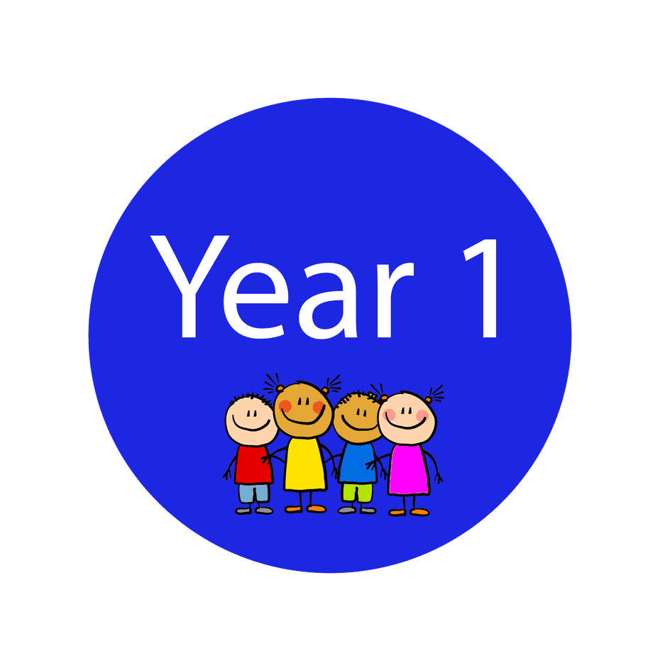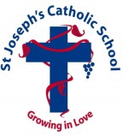Homework

Friday 12th September 2025

Word of the Week: Encounter

|  |
| --- |
| TOPIC – How Green Is Our School? |
| To support our learning in the classroom, please complete 3 pieces of homework from the separate topic homework grid.  Choose 1 activity from each column - Do it! Make it! Write it!  Although these do not need to be returned until Wednesday 8th October, you may wish to complete some of the tasks early so that we can photocopy and display your amazing work in class. |
| Maths |
| Have a selection of toys.  Can you sort them by colour? Type? Size?  Take photos of how you have sorted them. |
| Reading |
| Read with your grown up for approximately 5 minutes every day.  This can be any book, but please try to read your reading book to your grown up 3 times in the week.  Make sure your adult records your reading in your reading record book. |
| Spellings |
| Please have a go at the following spellings which we have been practising in our Phonics lessons |
| Science |
| In Science, we have been learning about parts of the body.  Play games and sing songs involving identifying parts of the body – e.g. ‘Simon says’ and ‘If you’re happy and you know it’ |
| RE |
| In RE, we have been exploring the Creation story of Genesis 1.  Please write about, or draw a picture to illustrate, one of the 6 days of creation. |
| Additional Information |
| This half term, the children will be accessing our Forest School provision on Wednesday afternoons. Please ensure that your child has suitable clothing. There is guidance on the school website about what the children will require for these sessions.  Please complete this homework by Wednesday 17th September. |