04.04.25
Homework to hand in on Wednesday’s and Friday new homework sent out.
RE | After Easter, the word of the week will be ‘Alleluia’. Alleluia is a joyful word that means ‘Praise the Lord’. At the Easter Vigil, we use this word for the first time since the beginning of Lent to show that we can now celebrate the resurrection of Jesus Christ and the victory of life over death.  Over Easter, think of a possible scripture reading and response that could be used in our child led celebration of the word.
Reading | Read your reading book daily and fill in your reading record. Make sure you get an adult to sign your reading record.
Geography | We are starting our new topic ‘What Makes Britain Great’ after half term. As part of this, we will be spending an afternoon in the school garden. If you have any seeds or bulbs you would like to donate, please send them into school on Monday 28th April. Thank you.
PE | Last week, we completed the Wow Active assessments. The new challenge cards have been sent home, please have a go at the activities over the Easter break.
Maths | Convert the fractions into decimals.  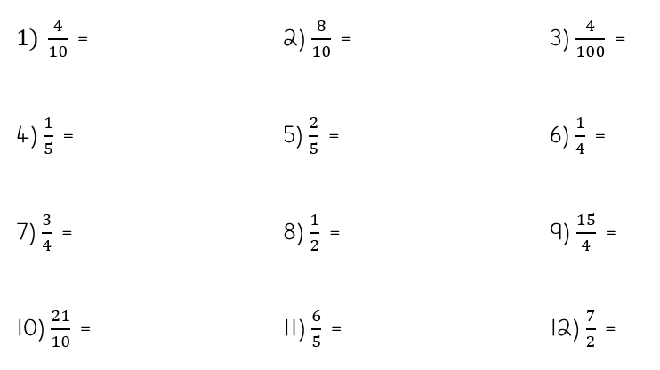

Our first Forest School session will be Tuesday 29th April. Please come to school dressed for Forest School and bring your school clothes to change in to after the session. A letter will be sent out on Marvellous Me to inform you about Forest School clothing requirements. Thank you.

