02.05.25
Homework to hand in on Wednesday’s and Friday new homework sent out.
RE | Next week, the word of the week is ‘Faith’. Having faith can be hard. It requires us to believe in those things we can’t prove and see. St. Thomas is famous for not believing that Jesus had risen, but this reminds us all that even for Jesus’ disciples, faith wasn’t always easy. Faith is a gift from God and if we can find it, and hold on to it, faith will give us strength, comfort and hope.  Think of something you need to have faith in this week. Spend a moment of prayer, asking God for help.
Reading | Read your reading book daily and fill in your reading record. Make sure you get an adult to sign your reading record.
English | We have been practicing using apostrophes to show possession.  Write 5 sentences, which contain apostrophes to show possession.
Maths | Convert the fractions into percentages.  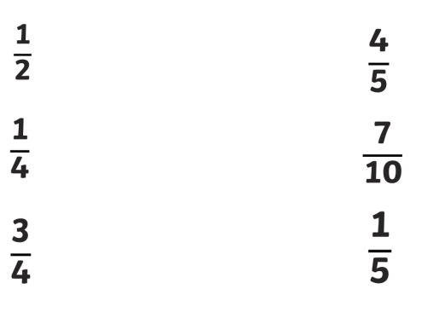

Tuesday is class photo day, as a result, there will be no Forest School on this day. Please ensure full school uniform is worn on Tuesday.
Forest School will take place on Thursday next week. Please come to school ready for Forest School. Bring a change of clothes in case children need to change after the session.

