**A Student Guide to Using Microsoft Teams**

# Section 1

How to use Teams on a Desktop or a Laptop

* How to log on
* How to upload an assignment
* How to access and respond to feedback given to you by your teacher

# Section 2

How to use Teams on a tablet or mobile phone

* How to log on
* How to upload a picture of work you have completed as an assignment

# Section 3

* Usernames and passwords for online platforms
* Helpdesk feature

## SECTION 1 – USING TEAMS ON A DESKTOP OR A LAPTOP Teams – How to Login

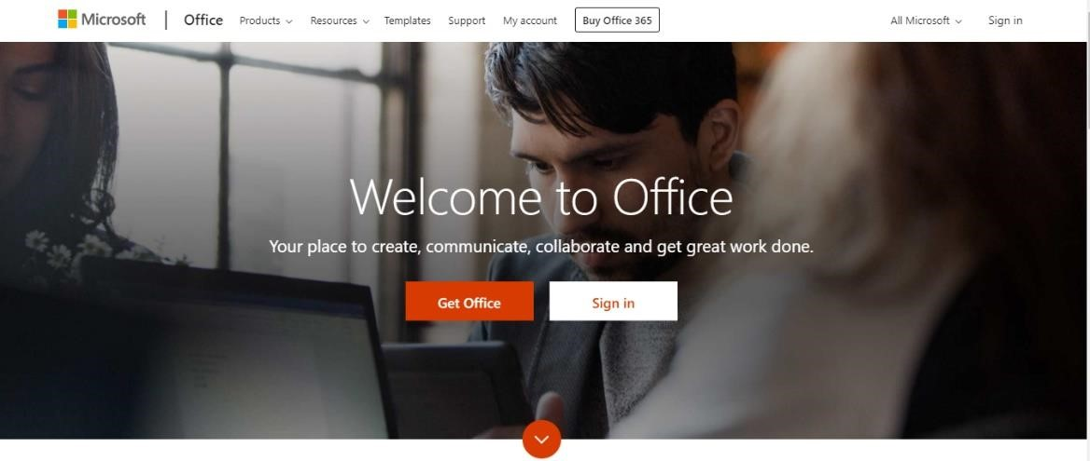Go to [www.office.com](http://www.office.com/)

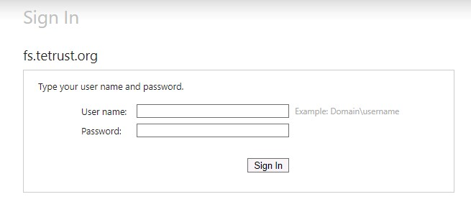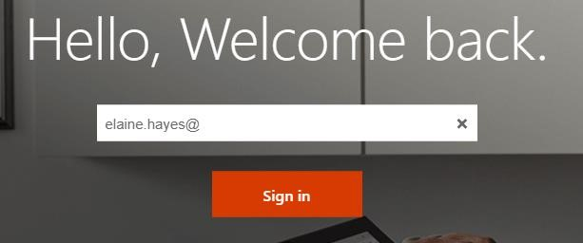

Click sign in and sign in with your full school email address which is your first [name.surname@st-joseph-pri.notts.sch.uk](mailto:name.surname@st-joseph-pri.notts.sch.uk)

Example: Hannah Baker’s email address would be

[Hannah.baker@st-joseph-pri.notts.sch.uk](mailto:Hannah.baker@st-joseph-pri.notts.sch.uk)

You will then be directed to the login page for the Trust – this is like if you are logging into a computer in school, so your username

is your computer log in you would normally use at school and the password is the one you set at school. Once you sign in, you will get the page below

Click on the Teams icon

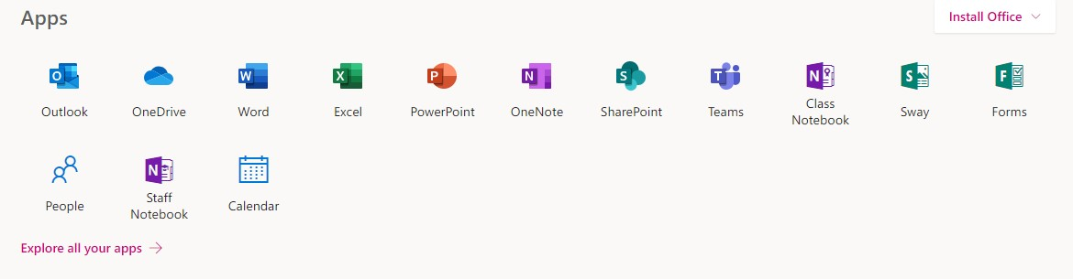

You should now see all the Teams that we have set up for you at school. You can also install the desktop version of Teams for free.

## Teams – Uploading an assignment

Your teacher can set assignment for you to complete. You will see a new notification every time your teacher sets a new assignment for you, which is circled in blue. By click on this notification, you will be brought to the

assignments page. You can also click the assignments button in the left-hand menu to see all the different assignments set by your teacher, or you can click into your class and click on the assignments button circled in yellow.

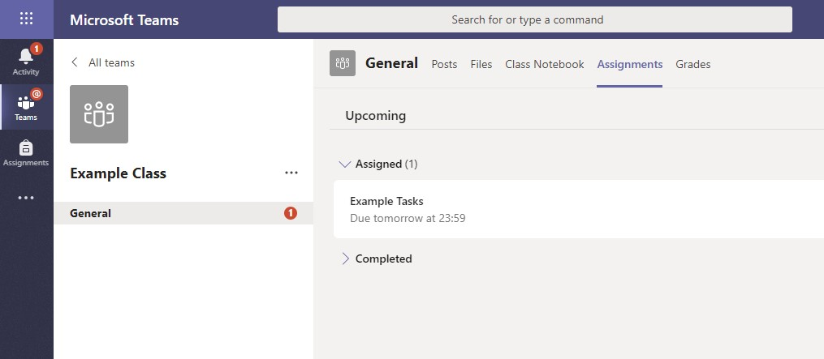

Click on the assignment to access the task.

To add some work, we first need to create a new document, then complete our work in it.

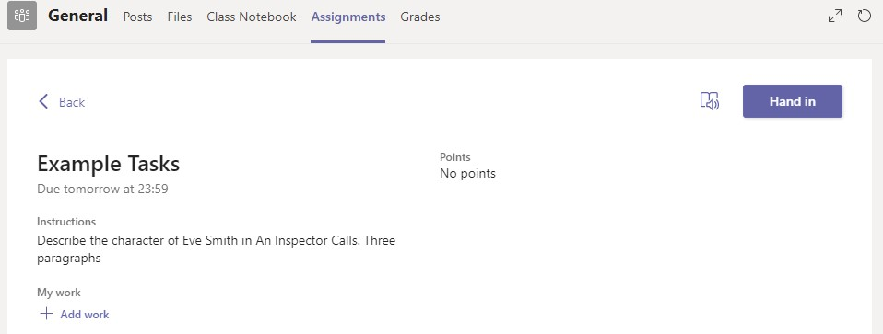

Using a new file

Click on new file and

decide w

ha

t format

you

will be submitting your

work

, Word, Powerpoint

or Excel

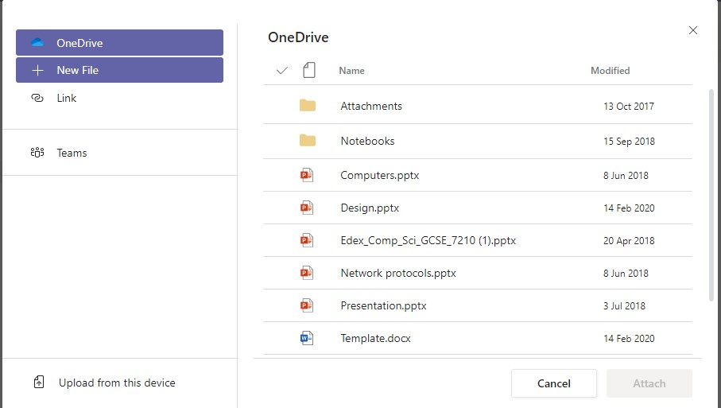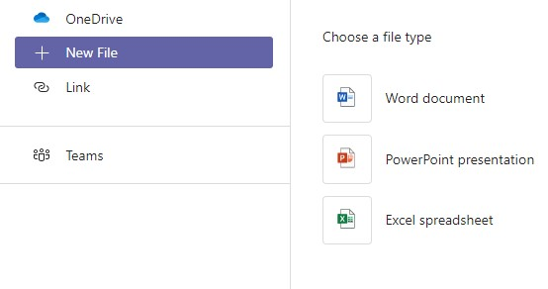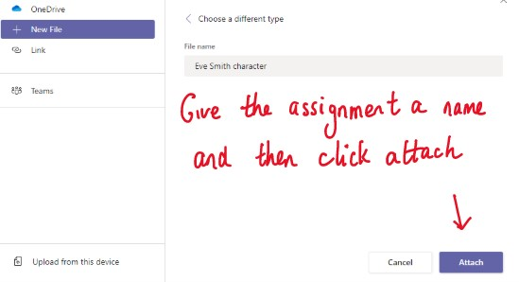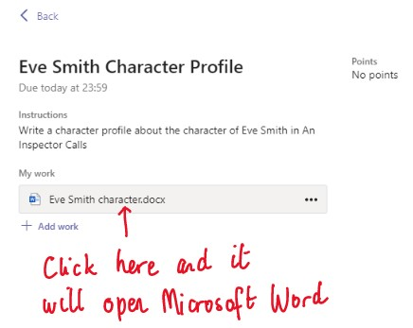

You have now created your document that you can start writing your work into. To start your work, click on the document name.

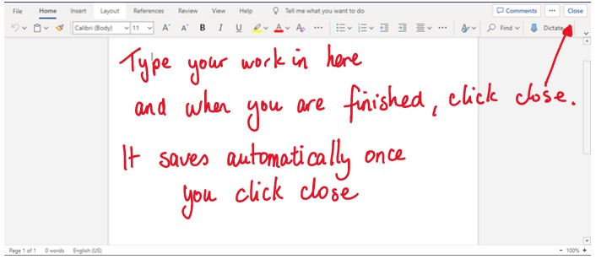

Make sure that you have

your work attached

and

that it is not blank

.

Click the hand in

button. Your teacher

can now look at your

work and give you

feedback if required.

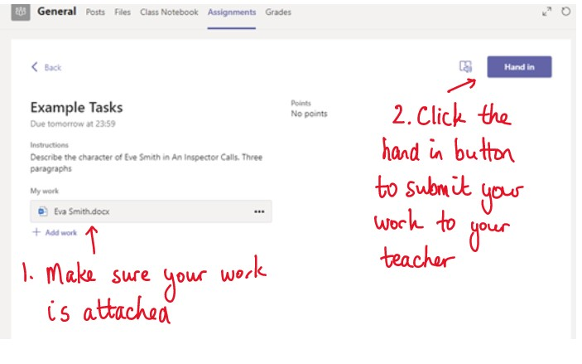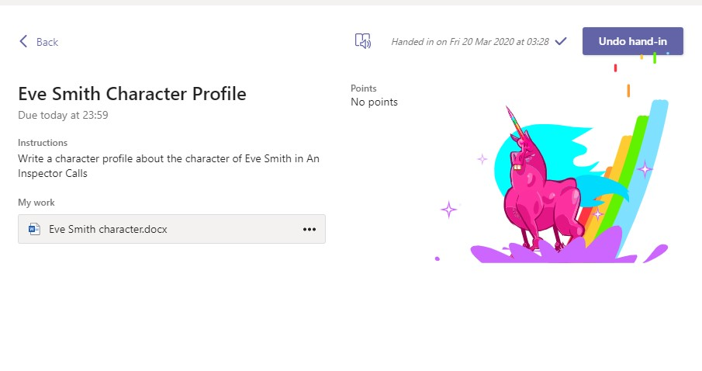

If you have successfully handed

in your work, you will see an

animation

–

there are loads of

different types!

**Teams – Getting feedback and responding to feedback**

You will get a notification in your

activity feed when a teacher has set

you a new assignment or sent you

feedback on your work.

Click on the Activity button and it

brings you to your feed. Any message

in

**bold**

you have not read

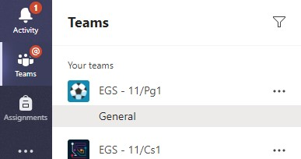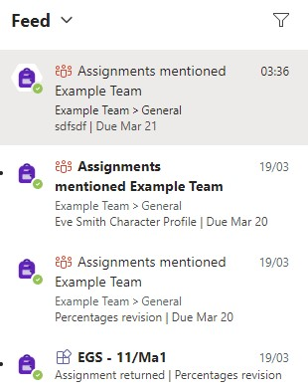

This is a notification to say that

there is a new assignment in

the Example Class that you

need to complete

This is a message to say that work has

been returned in this student’s maths

Team

–

to see the feedback, click on

the notification

This piece of work has been looked at by this student’s teacher and been given some feedback circled in red. You can click on the file to open it and act on the feedback given to you by your teacher, before handing it in again.

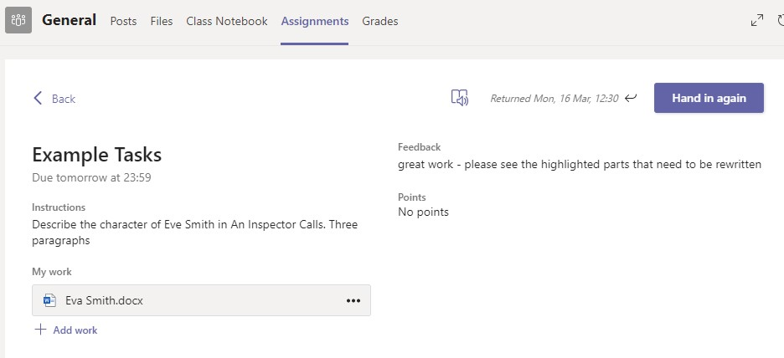

## SECTION 2 – USING TEAMS ON A TABLET OR PHONE Teams – Downloading the Teams App

The Microsoft Teams app is available for free on the

App Store (iPad and iPhone) or Google Play store

(

Android tablets and phones). Search for Teams and

look for the purple Teams icon circled in red and

download.

Once it is downloaded, open the app and

log in.

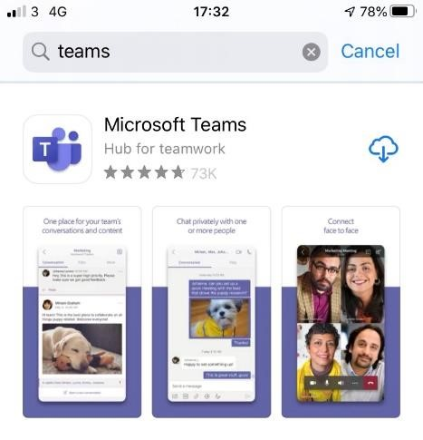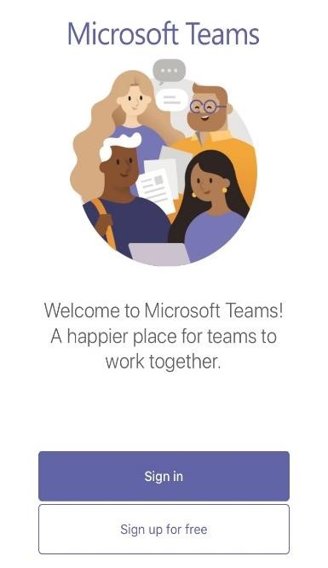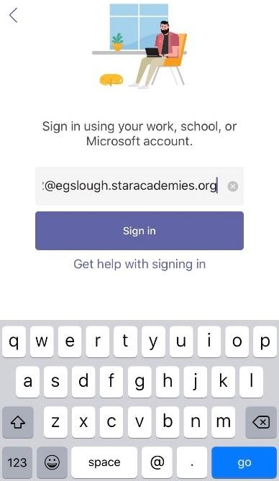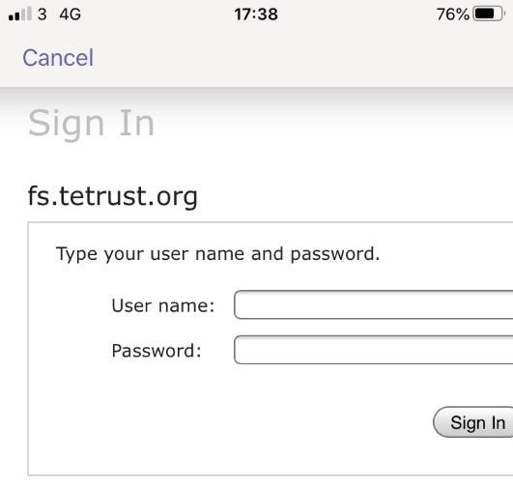

Sign in with your school email address which is your first [name.surname@st-joseph-pri.notts.sch.uk](mailto:name.surname@st-joseph-pri.notts.sch.uk)

Example: Hannah Baker’s email address would be

[Hannah.baker@st-joseph-pri.notts.sch.uk](mailto:Hannah.baker@st-joseph-pri.notts.sch.uk)

You will then be directed to the login page for the Trust – this is like if you are logging into a computer in school, so your username is your computer log in you would normally use at school and the password is the one you set at school.

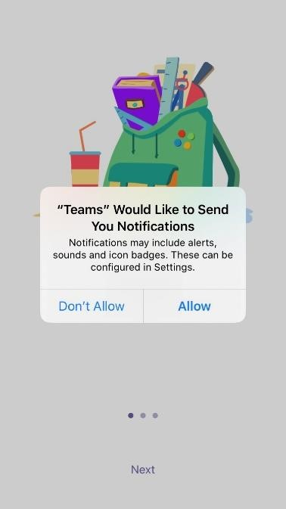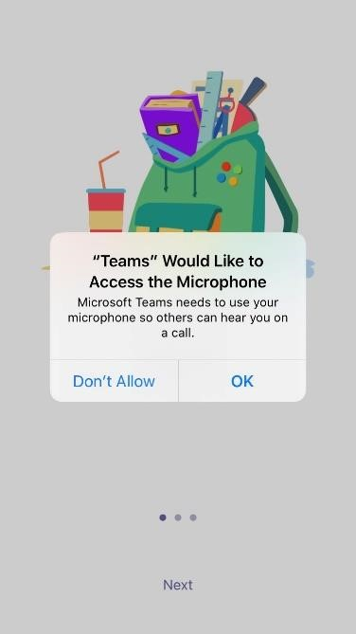

Turn on notifications for Teams so that you get an instant notification when your teacher has set you a new piece of work, posted an important message or sent you some feedback on work you submitted. If you are joining a virtual classroom you need to click allow, but during the virtual classroom, you will be turning the microphone off.

## Teams – Uploading an Assignment

If you are uploading a document, follow the guide that is in section 1 as uploading a document from a phone or tablet is the same process. However, if you have piece of written work that you need to upload, you can use your tablet or phone to take a picture of your work. You can find the assignment you have been set in two places - the activity feed and assignments – picture 1.

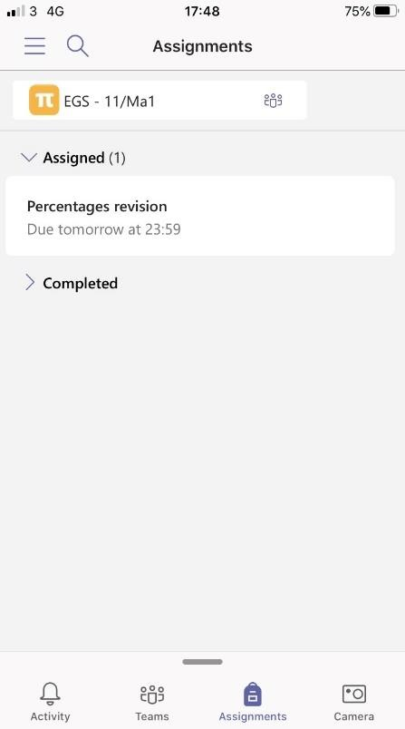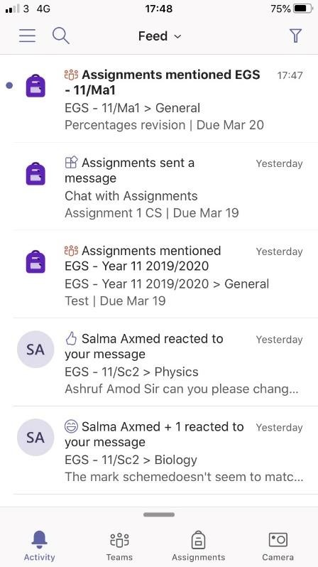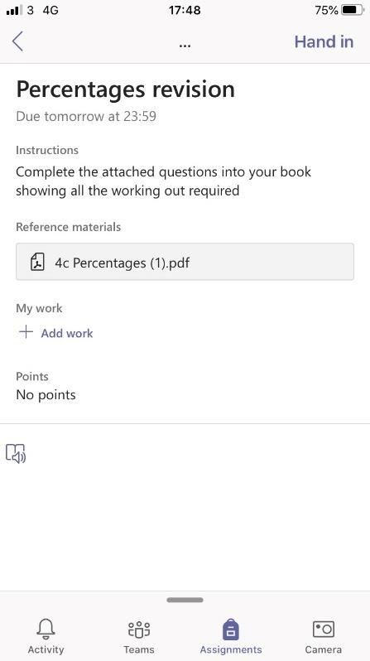

Tap

on the

assignment to

open it

1

2

3

Press

on add work

to add a picture

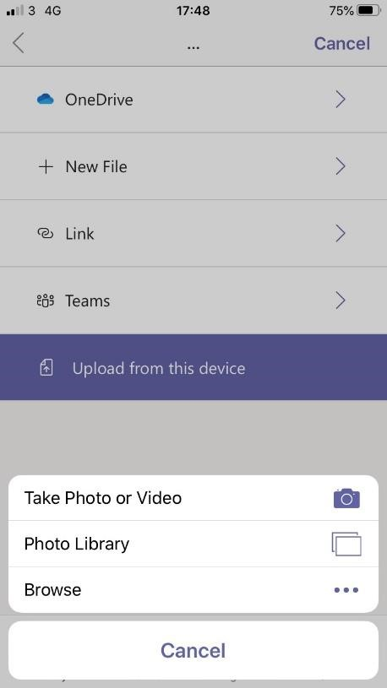

4

Press

on

upload from

this device

and then

take photo or

video

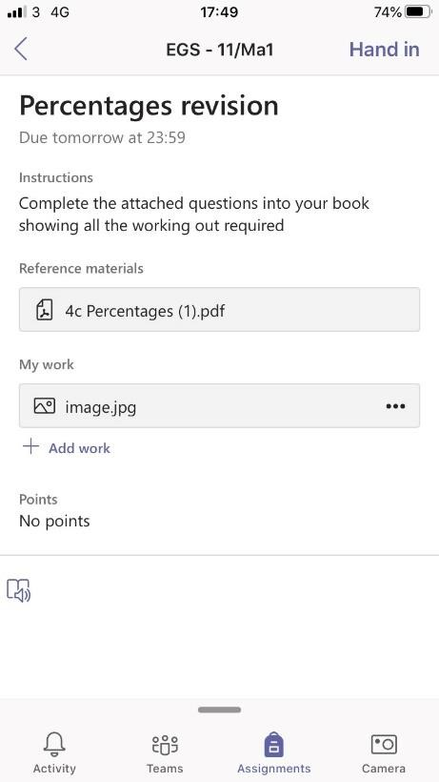

Take the photo and

attach it, making sure

it is attached to your

work and press hand in

5

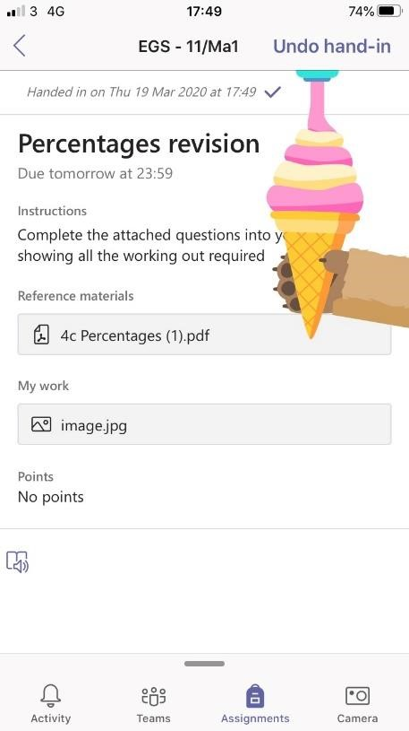

Make sure you see

the animation that

confirms you have

handed your work in

6

## SECTION 3 Usernames

### Office 365

For Office 365 and Teams, you will log in with your school email address.

Click sign in and sign in with your full school email address which is your first [name.surname@st-joseph-pri.notts.sch.uk](mailto:name.surname@st-joseph-pri.notts.sch.uk)

Example: Hannah Baker’s email address would be

[Hannah.baker@st-joseph-pri.notts.sch.uk](mailto:Hannah.baker@st-joseph-pri.notts.sch.uk)

### ActiveLearn and GCSEPod

## Helpdesk

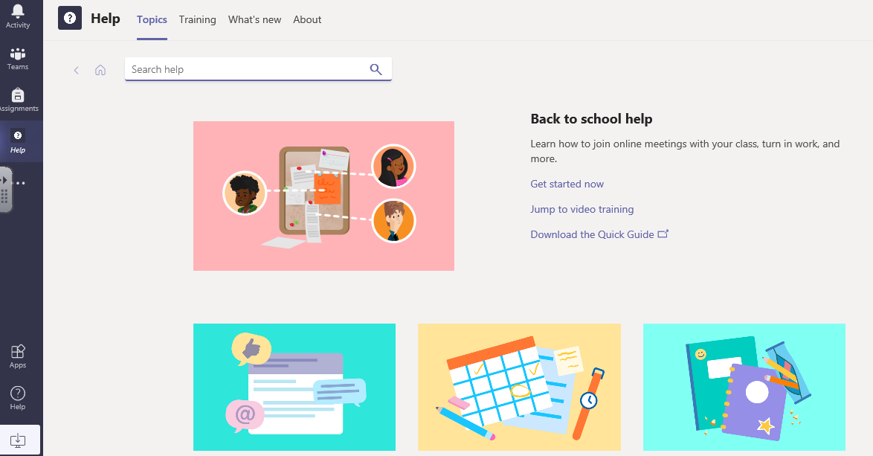

After pressing on the help icon, it will take you to the help desk. From here, press on the topics icon where you can find help tutorials.