Year 4 Homework
Due: 20th November 2024
Maths  What is the area of these shapes?  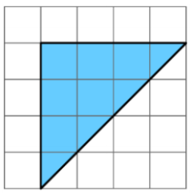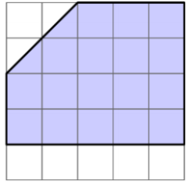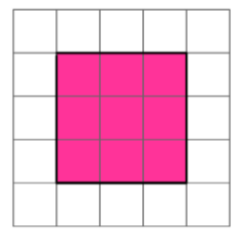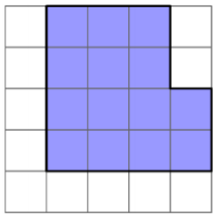 | English  Soon, we will be starting our independent writing.  Oracy Focus  Our word of the week is  Youth  Why must we give focus to our youth?  You will need to choose a historical time period to write about.  Start doing some  research about your  chosen time period. You  could find out about:  *A dramatic event  *Famous landmarks  *Daily life
Times Tables  By the end of Year 4, you should aim to know all of your times tables up to 12 x 12.  4 x 5  8 x 4  12 x 8  10 x 8  9 x 2  6 x 5  3 x 7  2 x 7  11 x 9  12 x 11  Please remember to access TT Rock Stars too! | Spellings  You will be tested on spellings which follow the same patterns as the ones below.  However, the spellings that I test you on may include words which are different to the ones below:  These words are all adverbs of place.  Above  Below  Around  Nearby  Forwards  Backwards  Everywhere  Up  Down  Back

