**How Green is Our School?**

**Geography topic homework is for the whole half term. You can bring in the homework at any time; please choose 2 of the items to complete.**

**Create:**

* **Create a model of our school.**
* **Create a poster about how we can look after our planet.**

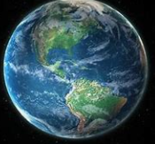 **Write:**

* **Write about ways we can look after the environment, at school.**
* **Write a letter to people in school about how important it is that we look after the planet.**

**Do:**

* 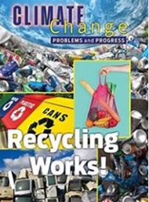**Take pictures of things you have done to be more ‘green’ at home.**
* **Visit the library and find books about looking after the planet.**

**I am looking forward to seeing all of your great ideas.**

**Mrs Gee 😊**