27th September 2024
Homework to hand in on Wednesday’s and Friday new homework sent out.
RE | Our current RE topic is ‘Families’.
Reading | Please read ten minutes per day from reading book given.
Spellings | Please continue to recap phase 2 or 3 tricky words. Below are phase 4 tricky words to practice as well.  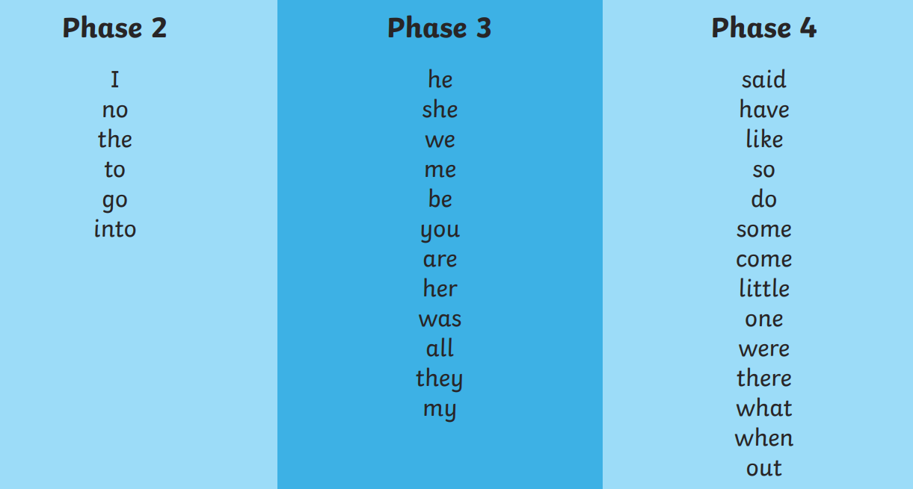
Handwriting | Please continue to practice handwriting in the booklets sent home. Please make sure every letter your child writes, starts with a leading line from the line they are writing on.
Maths | In maths we are comparing numbers, using the language greater than, less than and equal to. Write some sentences using these phrases.  For example:  4 is less than 8  6 is greater than 2  5 is equal to 5
Topic | Topic homework this half term is geography, and is included on a separate sheet, you can bring this in anytime over the half term.

Any questions, please ask. Mrs Gee

