Year 4 Homework
Due: 25th September 2024
Maths  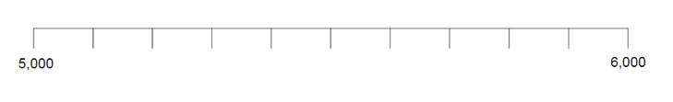  Draw a number line from 5000 to 6000, like the example below:  Place these numbers  on the line:  A: 5200  B: 5400  C: 5750  D: 5999  E: 5040 | English  Choose four pronouns from the list below and use them each in a sentence. Add Rainbow Grammar colours if you can!  he, she, it, they, I,  we, you
Times Tables  By the end of Year 4, you should aim to know all of your times tables up to 12 x 12.  6 x 5  4 x 2  9 x 5  11 x 6  8 x 5  9 x 3  2 x 10  8 x 8  5 x 5  10 x 10  Please remember to access TT Rock Stars too! | Spellings  Oracy Focus  Our word of the week is  Understanding  How can you have understanding for others?  You will be tested on spellings which follow the same patterns as the ones below.  However, the spellings that I test you on may include words which are different to the ones below:  These words all use the prefix -il or -ir.  Illegal  Irresponsible  Irregular  Irrelevant  Illogical  Irrational  Illegible  Illiterate  Irreconciled  Irrespective

