FS2  
Class information   
2024  
Spring Term One

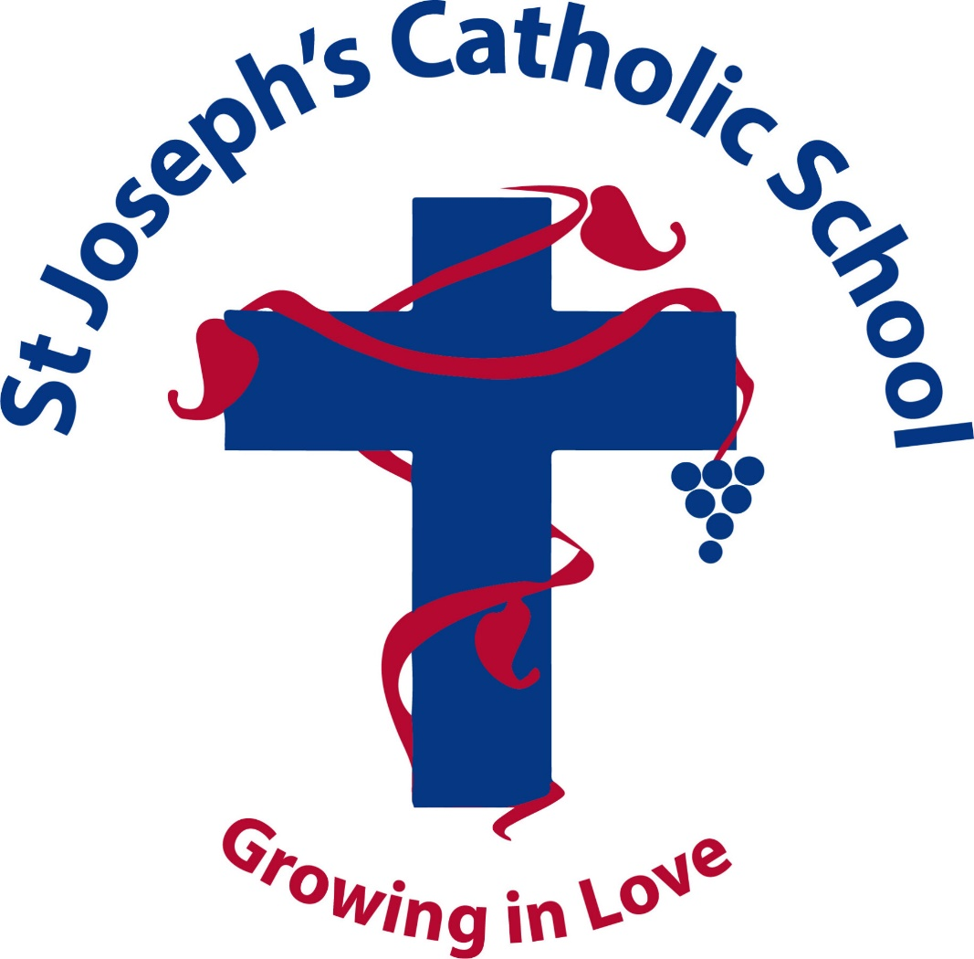

St Joseph’s Catholic Primary and Nursery School.

We hope you have all had a peaceful and relaxing break and are ready to begin another exciting term. For the first half of the Spring Term our topic is Long ago we begin our topic all about how we have grown, starting with our baby photos guess who game

**STAFF**

There are 2 adults that you will meet during your time in Reception:

1 Reception Teacher: Miss Beveridge  
2 Teaching assistant: Miss Croucher  
We will also be joined by Miss Robinson, for one day a week completing her final year as a teaching student.   
4 Lauren Kendrick is our new teaching student, she will be joining us for her 10 week placement.   
5, Chelsea Grayson (student) who will continue to attend every Thursday and Friday until June.

**Session Times**

Start time 8:30am until 3:30pm Please use our F2 entrance to drop children off.   
We will now introduce a morning greeting with our children every morning as they arrive. Now that our children are settled into our routine, every morning a challenge will be set for your child in the class room at 8:30am-8:45 therefore it is important that children are prompt so that they are able to complete their morning challenges each day, these will include a fine motor activity, a reading activity, or a maths activity.

**Our School website**

Photos will be uploaded to the school website on our class page with activities we will be taking part in this term, and a copy of the homework will also be attached in the home learning section, and a copy of our medium-term planning will also be uploaded to our class page. We also use Marvellous Me to keep in touch with you, and will be sending out lots of badges for working hard this term.

**MILK AND SNACK: Will my child need to bring any snacks?**

Milk is provided free of charge until your child’s fifth birthday. We use an online school milk system. Once your child turns five, you will be asked to sign up online with Cool Milk if you wish to pay for your child’s milk.

We also provide a variety of fresh fruit each day. You will not need to send in any additional fruit/ snacks.

Children need to bring a water bottle each day with water or sugar free juice.

**DINNERS: What happens?**

All children are entitled to a free meal provided for them by school. There is always a range of food available to cover many dietary requirements, including a vegetarian option.

**Uniform : What will my child need?**

* a navy jumper or cardigan with the school logo, • a white shirt, not a polo top as this is for PE only.
* grey skirt/pair of trousers.
* Please label all items of clothing, including coats and jumpers, as we might get a bit muddled up from time to time, especially now our children are learning to be as independent as possible and hanging up their own belongings etc.
* All children need to wear a school tie- (elastic ones are on sale in the office).
* Black shoes

In Reception, we do painting and gluing activities almost every day. We provide aprons, but please appreciate that your child might go home a little messy. We try to ensure our paint and glue is washable. However, if your child does get paint on their clothes, we recommend that you soak them in cold water first.

Please can we also remind you to send your children with a coat every day and with hats and gloves on colder days. As you are aware **EYFS** includes outdoor learning and so the children do spend some time outside every day, whatever the weather!

**P.E**

All children will have a weekly P.E. session. This takes place every Tuesday morning. Your child will need to arrive in their P.E. kit which must include:

• a white t-shirt,  
 • a pair of navy blue shorts/Jogging bottoms for winter and a pair of pumps.

The P.E. kits must be clearly labelled. Please help your child by helping them to manage their own clothes and footwear. All jewellery must be removed on P.E. days.

**Children need to bring their uniforms to change back into on PE days, which should be in a named bag with all uniform labelled**.

**Forest school**

Forest school will be taking place in February. Your child should come to school dressed in outdoor clothes on this day. Clothes may get dirty so ‘play clothes’ and old coats please. Children will need wellington boots for forest school, please bring in a bag. If children arrive in comfortable shoes that they can wear during the day in class as wellington boots are not comfortable for the whole day, and they could get very muddy. A separate letter will be sent home closer to the time.

**FOUNDATION STAGE CURRICULUM: What will my child do in Reception?**

In Reception, we believe in educating the whole child, focusing on intellectual, social, emotional, physical and creative growth, valuing the rich diversity of culture the children bring to the classroom. The curriculum is carefully planned with children learning through a combination of teacher/pupil initiated activities and play. We consider play to be an important educational activity enabling children to practise and consolidate a variety of skills.

Each day, your child will be involved in a wide variety of activities which will encourage learning in an enjoyable and stimulating way.   
  
There are seven areas of learning which must be included in the curriculum planning:

|  |  |
| --- | --- |
| **Spring 1** | |
| **RE** | **Celebration Gathering Growing**  We will also begin our RSE work this term and learn about Gods world (Creation) |
| **Phonics** | Children now will begin phase 3 phonics and will be introduced to new graphemes and tricky words every week. |
| **Happy Handwriting** | This term we will begin perfecting handwriting, concentrating on letter formation. We will begin by focusing on the long ladder family of letters first as they are the easiest for children to learn **l,t,I,u, j, y**. Then curly caterpillar letters **c, a, g ,q, o, e, f, s**. Then one armed robot family of letters, **r, n, m, p,** **h, b.** and finally zig zag family letters **v, w, x, k, z.** |
| **Topic** | **Long Ago**  This project teaches children about how they have grown and changed since they were babies and how life in the past was different from today. |
| **Maths** | White Rose maths scheme  Alive in 5  Mass and Capacity  Growing 6,7,8.  We will be learning about composition, more and less, ordering numbers, identifying missing numbers, using mathematical vocabulary. |
| **PE** | Dance |
| Outdoor Forest School  We have a forest school session each week. | Forest School builds on a child’s innate motivation and positive attitude to learning, offering them the opportunities to take risk, make choices and initiate learning for themselves.  We focus on the process, rather than the end result, tasks are open to exploration and encompass different learning styles. We nurture and fosters resilience creativity and independence in all learners  Being in nature promotes wellbeing- happier, healthier children are more open to exploring their world and problem solving in positive ways.  The children’s interests along with the varied natural resources in our woodland are used to stimulate creative thinking, problem solving and skill development, all under the premise of ‘play.’  Our Forest school learning environment provide experiences that encourages an appreciation, awareness and knowledge of the natural environment. |

**Keeping in touch**

At St. Joseph’s we are keen to establish a good relationship with parents and create a system where parents feel involved in their child’s learning.

As parents, you are the first educators of your child and at the school we recognise that the partnership between home and school is fundamental to your child’s success. School staff are always happy to speak to parents during the week before or after school, you can always contact the school using the school email or telephone.

Miss Beveridge