**Number and Place Value**

**Tens and Ones**

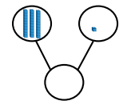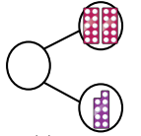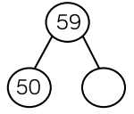

29

9

**Key Words**

tens

ones

partition

place value

part-whole model

digit

ten frame

31

80 + 0

40 + 2

10 + 6

20 + 19

16

39

80

42

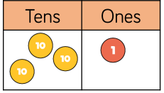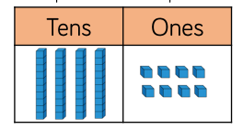

= 31

= 48