**Science Knowledge Organiser**

**Changes of Materials**

|  |  |
| --- | --- |
| **Key Vocabulary** | |
| solute | a substance that can be dissolved in liquid |
| solvent | a substance that can dissolve in a solute |
| reversible | a change to a substance that can be undone or reversed |
| evaporate | the process where a liquid changes to a gas |
| chemical change | a type of change in which a new substance is formed |
| effervescence | fizzing or bubbling |
| combustion | an irreversible change where a fuel uses oxygen to burn and releases energy |

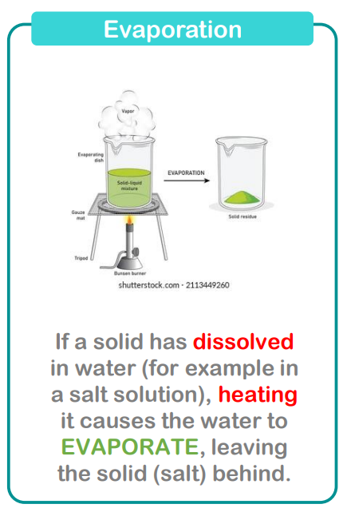

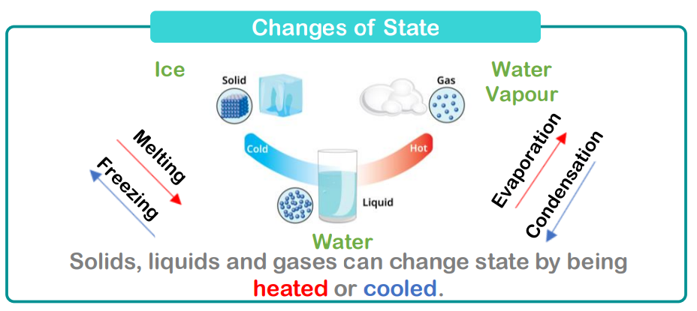

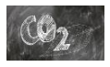Carbon dioxide is a gas which makes up around 0.04% of our atmosphere

Careers connected to changes of materials:

* laboratory technicians
* technical associates
* research analysts
* chemistry teachers.

